Posted 02/24/2011 at 9:00 am by JAV
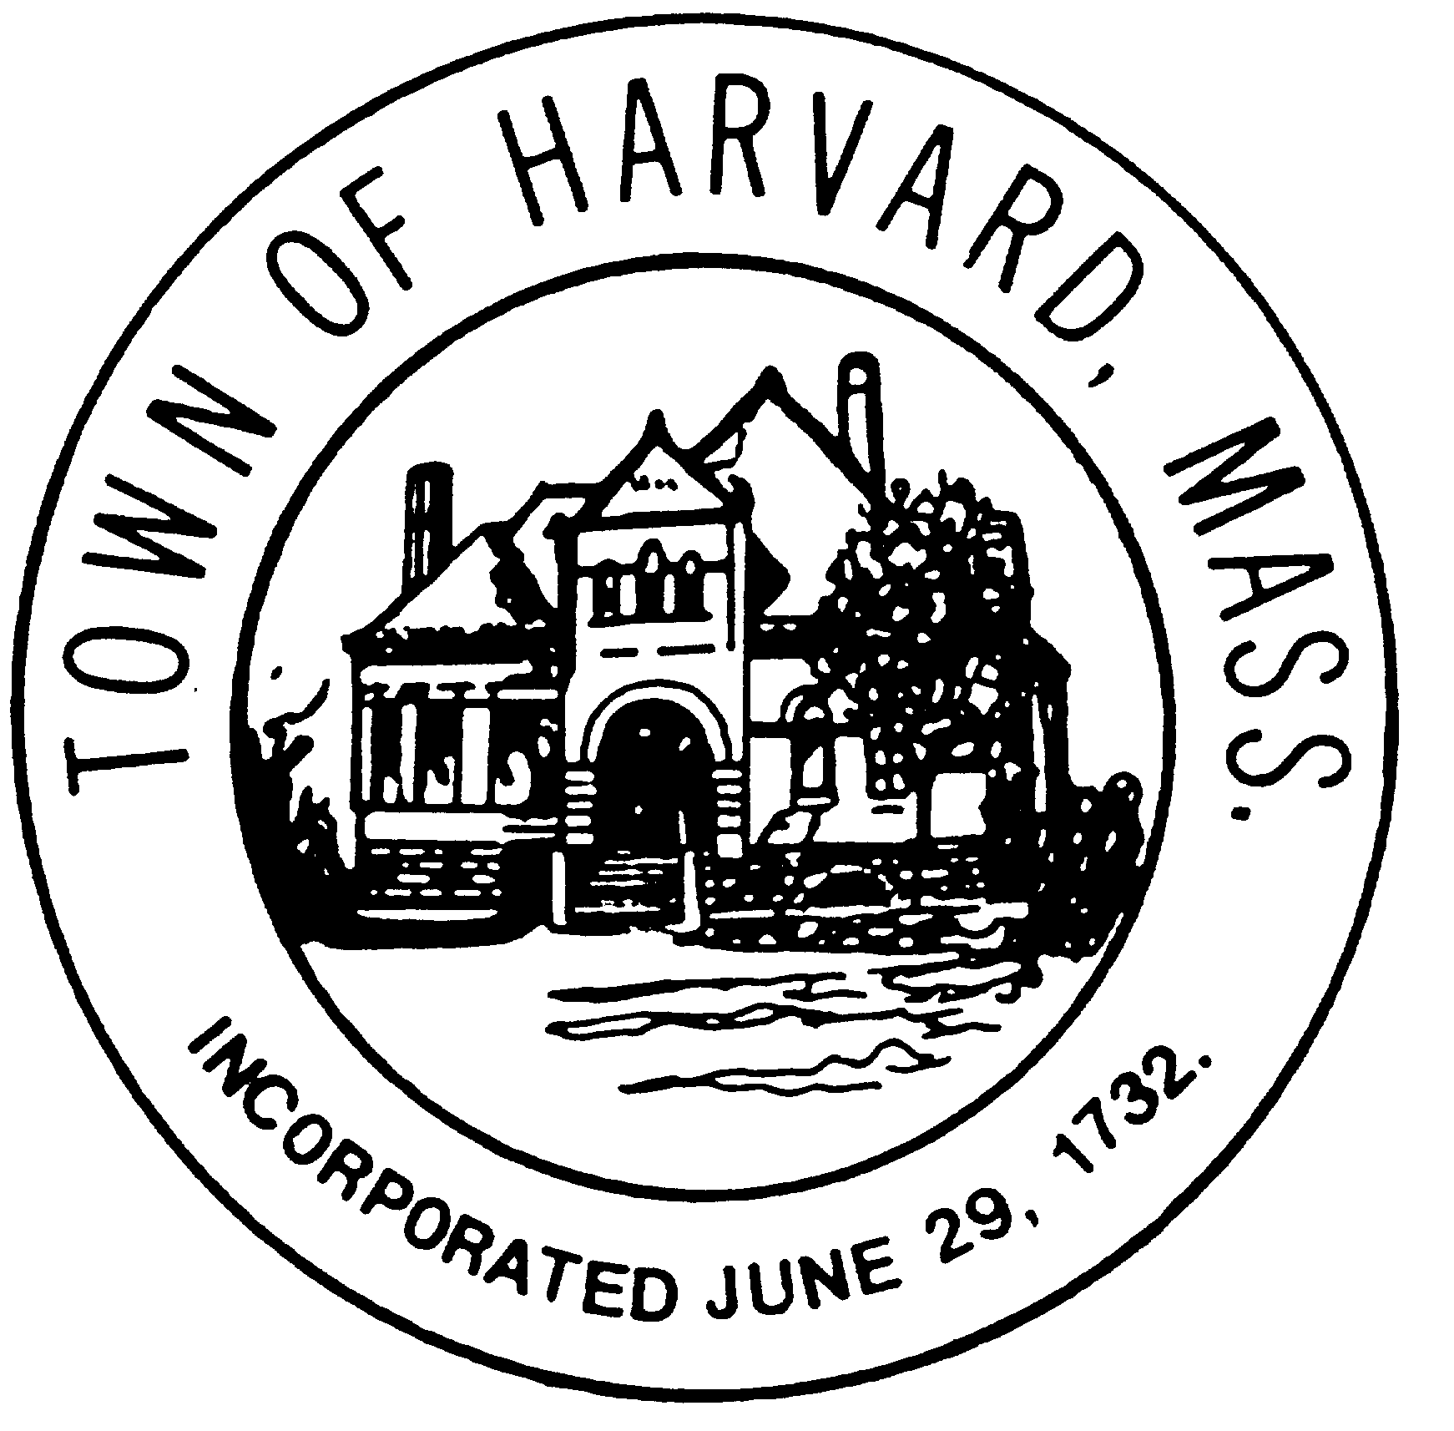

Board: Municipal Buildings Committee
Day & Date: Friday, February 25, 2011
Time: 9:30 pm– 11:00 pm
Location: Town Hall

Agenda:

- Review of presentation on February 17, 2011
- Preparation for presentation to BOS on March 1, 2011.
  - Refinement of cost/tax material
  - Reduction in length
  - Inclusion of drawings
- Review schedule and venues for ‘out-reach’ effort.
- Review of meetings with Boards and Committees
  - Planning Board – February 28
  - Others

